Birthmark Protocol Integration: Capture Device, Credential Validator and Edit Workflow
Sam Ryan
The Birthmark Standard Foundation
Portland, OR, United States
contact@birthmarkstandard.org
ORCID: 0009-0000-1862-0417
24 October 2026. Preprint, not peer reviewed. This version replaces the earlier version of arXiv 2602.04933.
ABSTRACT
The Birthmark Protocol paper gives a two-channel provenance architecture and proves eight privacy properties for it. It leaves the capture device, the credential validator and the edit workflow only partly specified. This paper specifies them: the packets a device builds, the token format, the validator’s keys, membership check and verdict policy, and the chain of records an edit produces. It states what the device costs, taken from published benchmarks, and says that no figure is yet measured on this design. It states which governance protections the protocol structure leaves necessary and which it already provides, without specifying how any deployment governs. It specifies the device routing table that assigns routes, and the generator-blinded keys with which a device addresses a destination without naming it. It states the limits: exact hashing, software-attested edits and per-manufacturer anonymity sets.
Keywords: Birthmark Protocol, media provenance, capture device credentials, credential validator, edit provenance.

1 INTRODUCTION
A provenance record has to survive the way media actually travels. Content Credentials, the C2PA mechanism for provenance, live in metadata, and the platforms where misinformation spreads routinely strip metadata through compression and format conversion [1]. A record stored outside the file does not depend on the metadata surviving, but a record store that links cameras to images is also a map of who photographed what. For the journalists, activists and sources a provenance system exists to serve, a breach of that map is the harm the system must not cause. The two requirements pull against each other, and the Birthmark Protocol is built to meet both [2].
The Protocol paper gives the architecture and the machine-checked privacy properties. A capture device sends a content channel and a credential channel on disjoint paths, and no single component holds what it takes to link a device identity to the content. This paper gives the device and validator specification that those properties assume. It cites the properties by letter (Properties A to L of the Protocol paper) and does not restate their proofs.
This paper makes five contributions. First, the device capture procedure and the token and packet formats (Sections 3.1 to 3.4, 3.10 and 3.11). Second, the device routing table that assigns routes and the Channel Keys with which a device addresses a server (Sections 3.5 to 3.9). Third, the validator interface, its keys and its verdict policy (Section 4). Fourth, the edit workflow, with parent links and optional fields, which turns an edited image into a new chained record (Section 5). Fifth, the timing parameters behind the Protocol paper’s traffic evaluation (Section 7), and a stated cost for the device with a list of what is calculated rather than measured (Section 8).
Section 10 states governance requirements. Section 11 states the limits.
The system verifies hardware origin. It does not verify that a scene is truthful. Staged scenes, and photographs of screens, prints and projections, pass verification.

2 SYSTEM RECAP
This section gives the architecture needed to read Sections 3 to 6. Two channels travel on disjoint relayed paths. The credential channel goes to the credential channel server (C). The content channel goes to two content channel servers (F and I). Table 1 lists the roles. A Registry Node is a consortium member’s node, and that member is its operator. It can serve as a first relay, second relay, C, F, I or gatekeeper, and it takes part in registry consensus. Validators are not Registry Nodes. Figure 1 shows one transaction.
Table 1. Roles. The Protocol paper (Table 2) gives the full descriptions.
Role | What it does
Device | Builds one credential packet and two content packets and wraps each for its first relay. Holds one credential. Signs nothing.
Relays | Forward opaque payloads. Only the first relay sees the device IP address.
Credential channel server C | Receives the credential packet. Wraps FullPacketHash under the device’s single-use key (BlindShare_key), sends the result, Enc_FullPacketHash, with the encrypted token to the validator, ring-signs the returned verdict with FullPacketHash, and fans out to three gatekeepers.
Credential validator V | Decrypts the token, checks the credential is registered, checks that the token’s binding hash matches Enc_FullPacketHash, judges the Processing Claim (the claim), and ring-signs the Modification Verdict (the verdict) together with the still-wrapped FullPacketHash (Enc_FullPacketHash). Never reads FullPacketHash.
Gatekeepers (three) | Verify the validator’s signature and C’s ring signature, hold, bundle, and post to their paired match boards.
Content channel servers F and I | Receive the content packets, compute FullPacketHash, and wait for a two-of-three board quorum before submitting to the registry.
Birthmark Media Registry | Finalizes a record once two submissions from two distinct servers agree, and stores it.
The Full Packet Hash, written FullPacketHash, is SHA-256(ContentHash ‖ n ‖ flags ‖ [h(metadata)] ‖ [parent ContentHash]). Here flags is the Optional-Field Flags byte and h(metadata) is the Capture Metadata Hash (Section 3.3). FullPacketHash is the only value the two channels share. Figure 2 shows who holds what. Figure 3 shows which key protects each message.
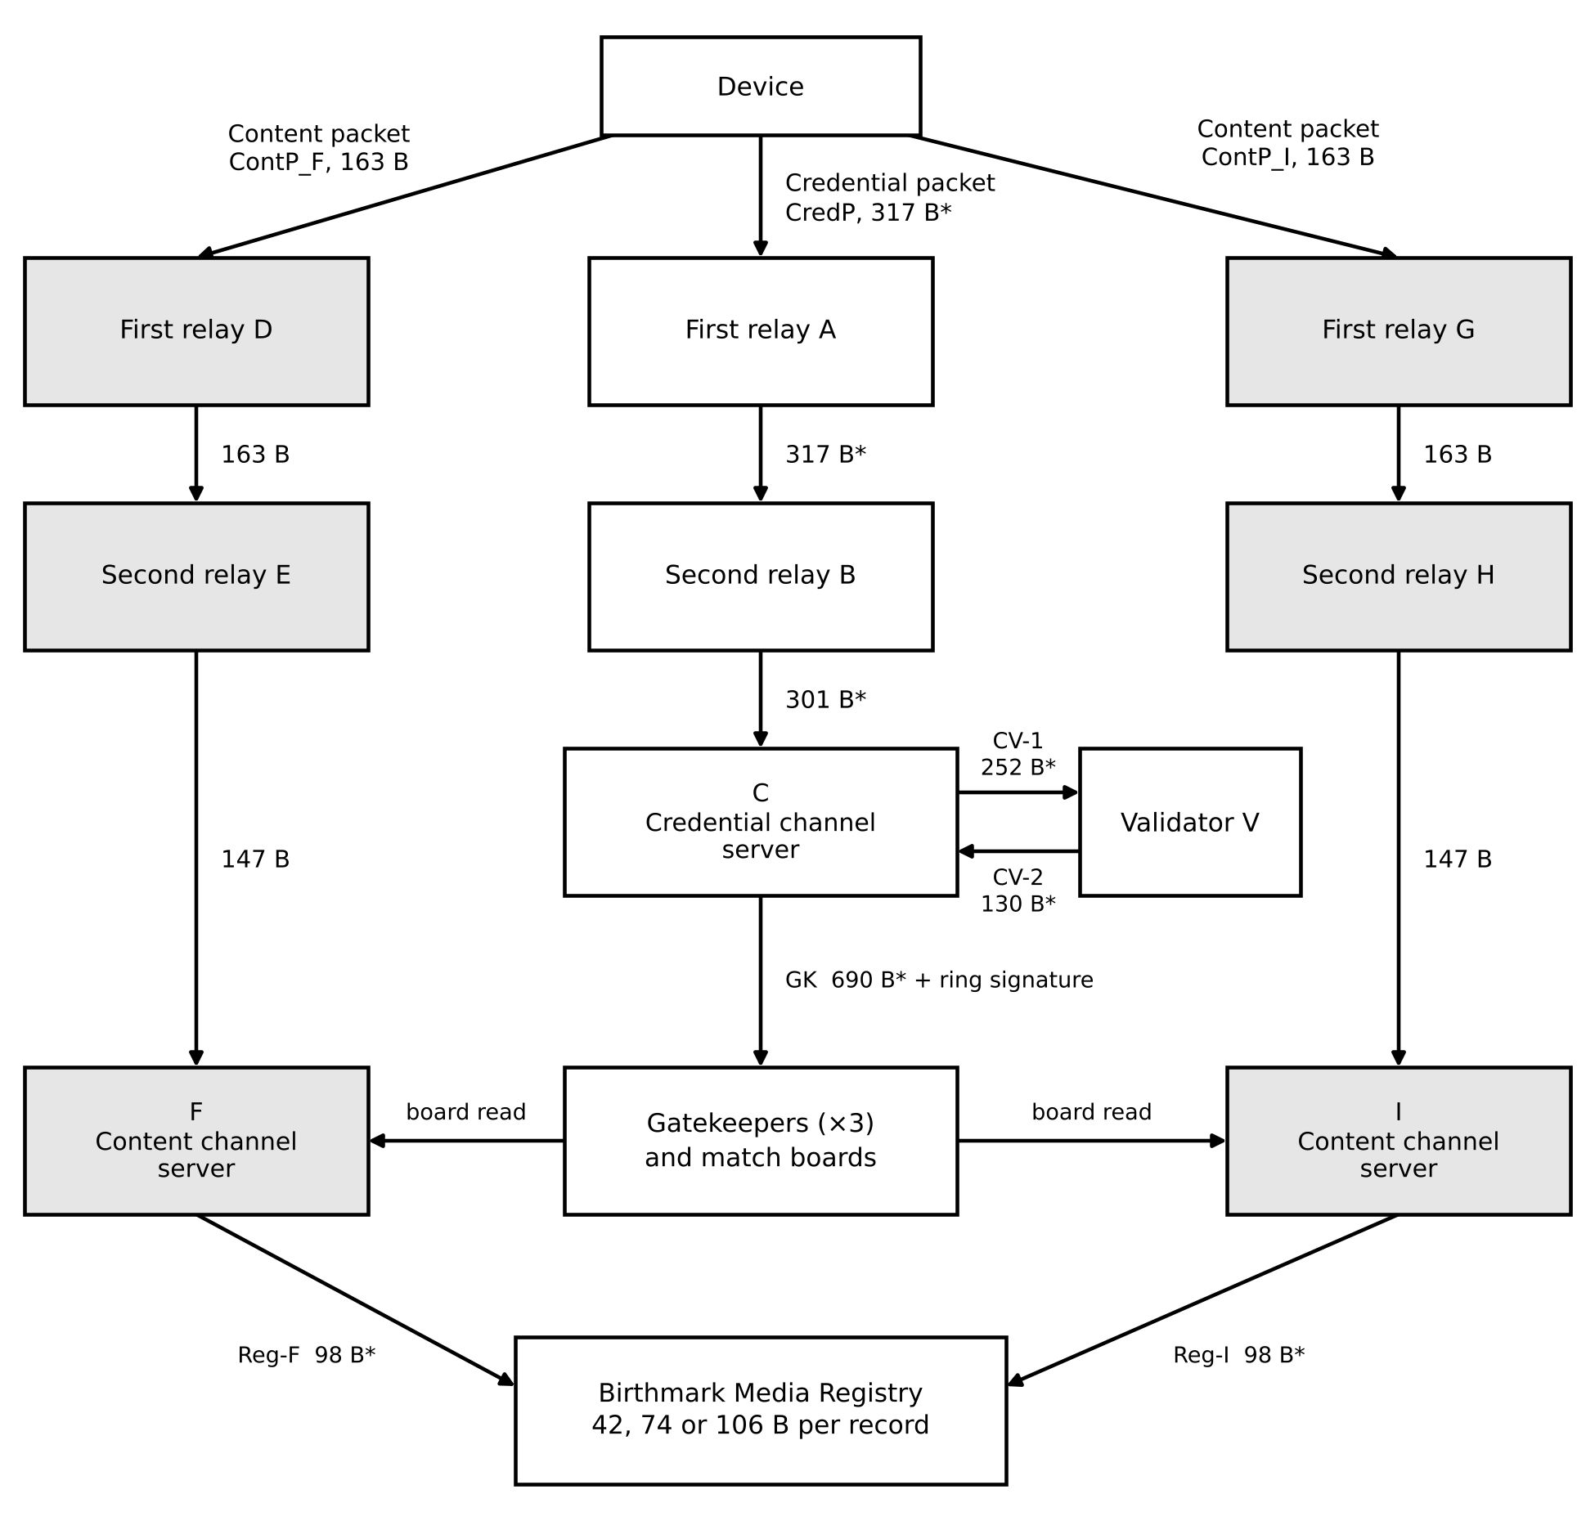
Figure 1. Message flow of one transaction. The device addresses only the first relays A, D and G. The table builder assigns the second relays B, E and H. Shaded boxes are on the content channel. Sizes are raw bytes before padding; starred sizes are estimates.
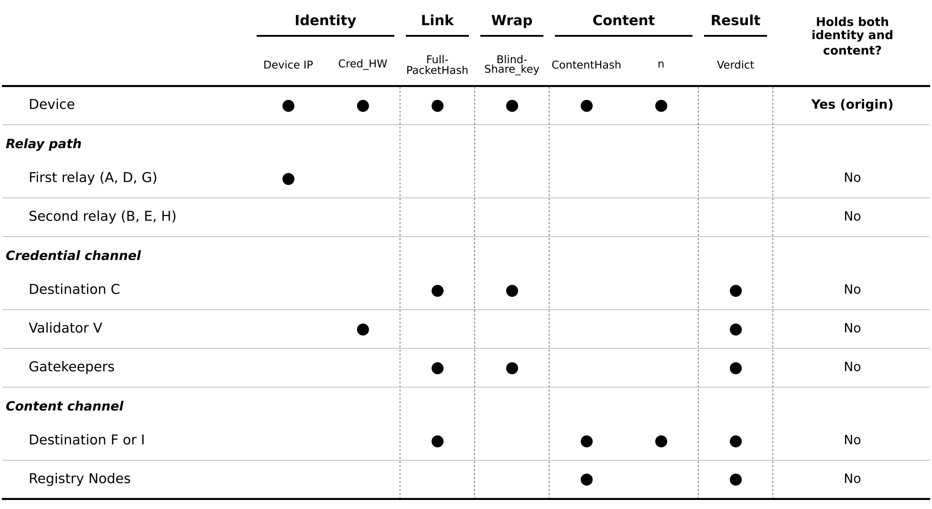
Figure 2. Who holds what, for one transaction. A dot means the party can read the item. No party other than the device holds both an identity item and the ContentHash, except where a first relay also serves as destination F or I (Section 3.5). V cannot read FullPacketHash because it does not hold BlindShare_key.
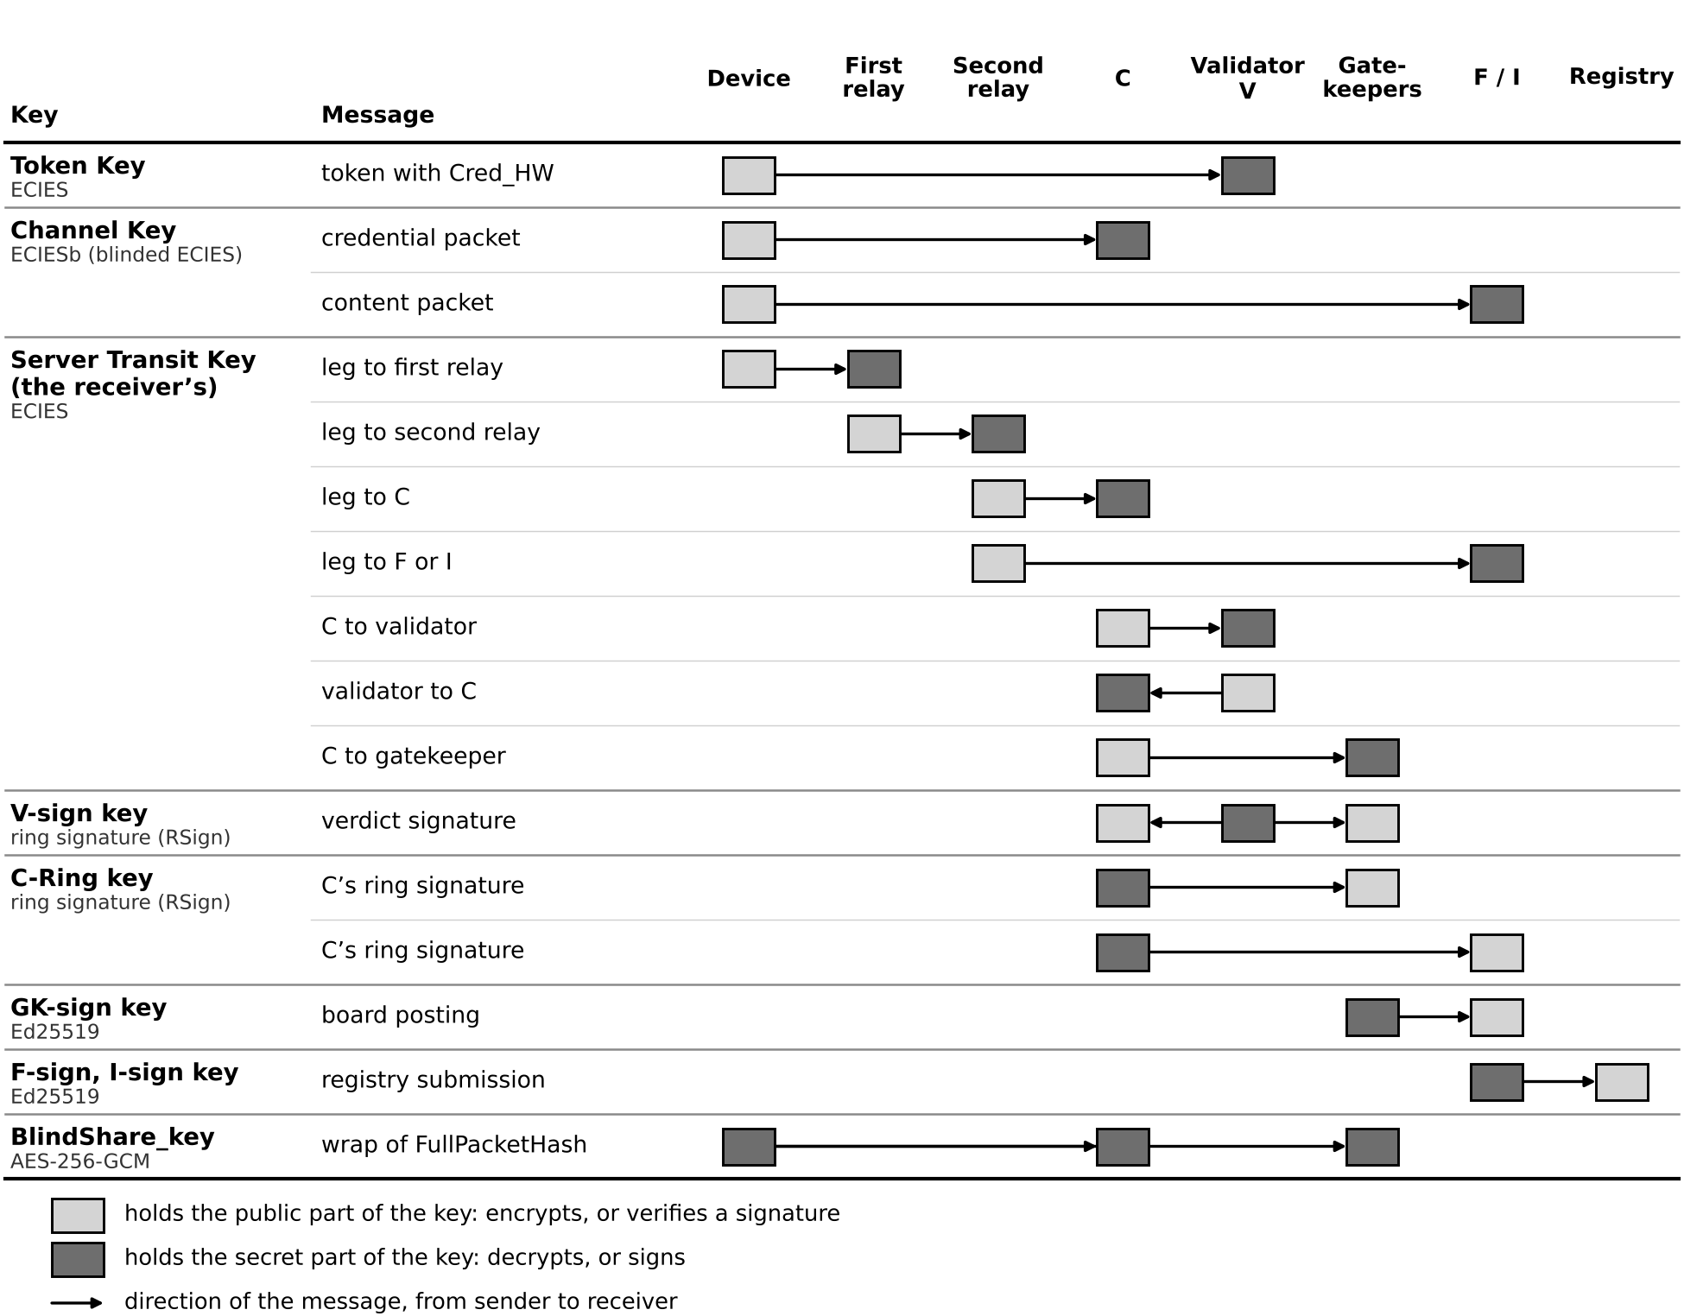
Figure 3. Which key protects each message. A line passes over parties that only carry the message. Every Registry Node holds a Server Transit Key and a C-Ring key, whatever role it plays. BlindShare_key is a shared secret, so every holder is dark.
The privacy properties, the gatekeeper quorum and the registry write rule belong to the Protocol paper and are not re-derived here.

3 DEVICE CAPTURE
This section specifies what the capture device computes, holds and sends. It ends at the device’s network boundary. The relay layer and everything behind it belong to the Protocol paper (its Sections 3 to 5). The device builds one credential packet (CredP) for the credential channel server (C) and two content packets (ContP_F and ContP_I), one for each content channel server (F and I), and wraps each for its first relay. It signs none of them. It holds no signing key and sends no verdict.

3.1 Credential Roots
The device holds one hardware credential, Cred_HW, a 32-byte secret known to its validator’s Token Key Table and to no one else. The validator decrypts the token, reads Cred_HW, and checks that Cred_HW is on the member list of the Token Key that the key reference (key_ref) names (Section 4.3). A Token Key is a key pair for one set of devices: they hold the public key, and the validator holds the private key and the list of their credentials. Nothing else authenticates the device. C never does, and the content channel servers never see the credential.
For a camera, Cred_HW is the hash of the sensor’s non-uniformity correction (NUC) map, NUC_hash = SHA-256(NUC_map), measured and stored at manufacture.
For a phone, the token carries Cred_HW itself, so the capture application must be able to read it. A credential the application can read is hardware-protected at rest and no further. For phones the requirement is that Cred_HW be a credential the validator recognizes, provisioned into hardware-backed storage. The mechanism is open. One alternative is a secure-element HMAC over the transaction nonce, which would keep the secret inside the element. It changes the token format and is not specified here.
The protocol assumes the integrity of the device’s Hardware Root of Trust (HRoT), meaning its secure element or manufacturing-calibrated hardware fingerprint (assumption A_HW in the Protocol paper). Replicating a manufacturing-calibrated hardware fingerprint takes physical access to manufacturing equipment, and no practical attack is publicly known. That is an empirical observation, not a bound. One consequence follows from the token design. Because Cred_HW is a bearer secret, anyone who extracts it from a device can produce valid tokens with fresh nonces until the manufacturer revokes it. The replay check does not prevent this. Revocation is the remedy (Section 4.3).

3.2 Hashes and Nonce
ContentHash is SHA-256 over the whole file as stored. The capture application computes it after it writes the final bytes, including the EXIF block and the metadata salts (Section 3.3). The write order is therefore: generate the salts, write the EXIF block, finalize the file, then compute ContentHash. There is no hash-mode flag and no per-device choice of algorithm, because a verifier who recomputes the hash locally has no channel through which to learn which algorithm a device used. A copy with its metadata stripped has different bytes and so has no record. It enters the system through the edit workflow (Section 5).
A capture can produce several candidate images: the RAW file, the ISP-processed image, or an adjusted version. Each candidate runs through its own transaction with its own nonces. Their records may finalize close together, so a registry observer could link sibling records to each other, though not to a device.
The content nonce n is 128 bits, drawn from a cryptographically secure generator (Section 3.11), and used once. It goes only to F and I. It is discarded once each check succeeds and is never posted to the registry. A party who obtains a FullPacketHash from a compromised log therefore cannot test candidate content against the registry, because recomputing FullPacketHash requires n.
FullPacketHash (Section 2) covers every field the content packet carries. A compromised content channel server that alters an optional field therefore produces a different FullPacketHash, which no gatekeeper quorum covers (Protocol Property H).

3.3 Content Packet
The content packet ContP_F (and its twin ContP_I) carries these fields, in this order, encrypted to the destination server with its Channel Key, from the device routing table line (Sections 3.6 and 3.8). The plaintext is flags ‖ ContentHash ‖ n ‖ [h(metadata)] ‖ [parent ContentHash]. The Optional-Field Flags byte also enters FullPacketHash, after n (Section 3.2). Appendix A gives the sizes.
- Optional-Field Flags (flags, 1 byte). Bit 0 is set if h(metadata) is present, bit 1 if the parent ContentHash is present, other bits zero.
- ContentHash (32 bytes).
- Nonce n (16 bytes).
- h(metadata) (optional, 32 bytes). See below.
- Parent ContentHash (optional, 32 bytes). Present only for an edit. The Certified Media Processing Software (CMPS), the editing software that takes the device role in an edit (Section 5.1), obtains it as described in Section 5.2.
The verdict comes from the validator and reaches F and I through the gatekeeper quorum. F and I read the Optional-Field Flags byte, recompute FullPacketHash from the fields present, and carry the Optional-Field Flags byte into the registry record.
The Capture Metadata Hash, h(metadata), is one 32-byte field. It is SHA-256 over three per-field commitments: timestamp, geolocation and owner. Each commitment is salted with its own random nonce, which is stored in the EXIF block inside the hashed file. The owner commitment is optional. Salting keeps the commitments independent, so a commitment to the owner does not link records by itself. The holder can later disclose one field by revealing its value and salt, without revealing the other two. The commitment fixes each value at capture. It does not make the value true: a device clock or GPS reading is what the device reported.

3.4 Credential Packet
The device token is T = ECIES(V-token_pk; Cred_HW ‖ replay_nonce ‖ claim ‖ binding_hash), where ECIES is the Elliptic Curve Integrated Encryption Scheme. The four inputs are:
- Cred_HW: the hardware credential (Section 3.1), 32 bytes. For an edit the CMPS puts Cred_SW in this field (Section 5.1).
- replay_nonce: a 16-byte single-use nonce, made of a 15-bit UTC day count, an offline bit and 14 random bytes. The validator refuses an out-of-range date and records the nonce to detect replay (Section 4.4). It is separate from n and goes only to the validator.
- claim (the Processing Claim): the CMPS’s statement about post-capture processing, two bytes. It is zero for a hardware capture. For an edit it holds the five class bits of the tools applied since the raw capture and the Deviation Score, the cumulative result of comparing the saved image with the Predicted Result of the declared operations (Section 5.3).
- binding_hash: the SHA-256 hash of Enc_FullPacketHash, 32 bytes. The device computes Enc_FullPacketHash = AEAD(BlindShare_key; FullPacketHash), where AEAD is authenticated encryption with associated data and BlindShare_key is a single-use 32-byte key that the device draws for this transaction. The hash ties the token to this one FullPacketHash. The validator compares it with the Enc_FullPacketHash that C sends (Section 4.4).
The device builds the credential packet CredP = ECIESb((GP, pk) of C; T ‖ key_ref ‖ FullPacketHash ‖ BlindShare_key), where (GP, pk) is C’s Channel Key, the blinded pair in the device routing table line the device uses for C (Section 3.6). The key_ref is an 8-byte identifier that tells the validator which Token Key and member list apply to the token (Section 4.3). C can read FullPacketHash and BlindShare_key and cannot read the token, because C does not hold V-token_sk. The validator can read the token but never receives FullPacketHash in a readable form, because C wraps it under the device’s BlindShare_key before forwarding and the validator never holds that key (Protocol Section 3.2). C cannot attach this token to a different FullPacketHash, because the binding hash in the token commits to the wrap of this one (Property L of the Protocol paper).
Each ECIES operation encrypts one layer. Table 2 lists them, and Figure 4 shows when each is applied and opened. The count is seven per capture, or fourteen elliptic-curve scalar multiplications. Layers 2 to 4 go to a destination named by a line of the device routing table. For these the device uses ECIESb, the generator-blinded form of ECIES. It picks a random scalar e, sends the Ephemeral Public Key EPK = e·GP with the ciphertext, and derives the AEAD key from e·pk. The destination derives the same key as sk·EPK (Section 3.8). A destination’s key for these layers is its Channel Key, the term the Protocol paper uses as well. In the reference instantiation the Channel Key is the blinded pair (GP, pk) of a device routing table line. Layers 5 to 7 go to a first relay, and every leg between servers is encrypted the same way, under the Server Transit Key of the receiving server. The leg from the device to the first relay (the initial submission leg) uses the first relay’s Server Transit Key, so the first relay holds no separate key for devices.
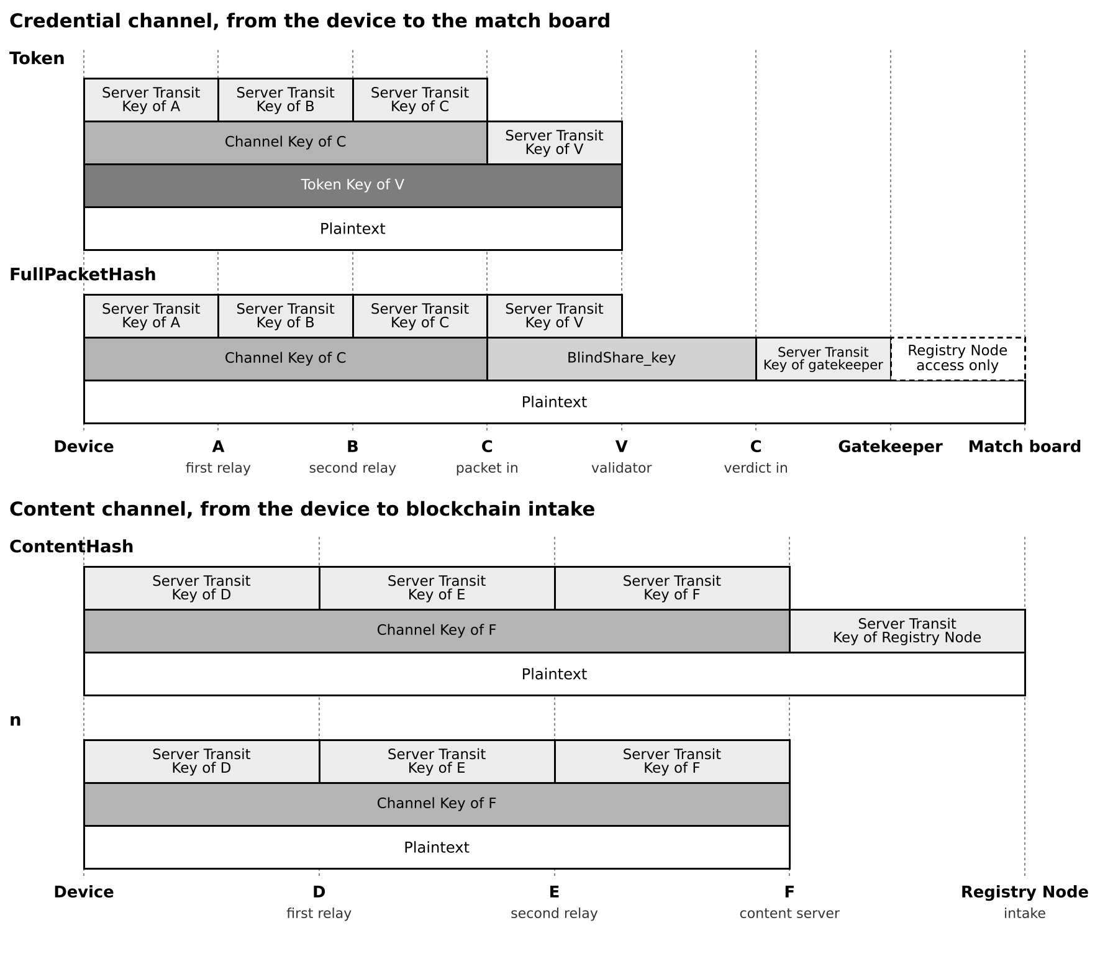
Figure 4. The encryption layers on each field at each station. A bar starts at the station that applies a layer and ends at the station that opens it. Layers stack in the order applied, the first at the bottom. A relay opens the Server Transit Key layer and applies the next. The Channel Key and Token Key layers stay on until C, F or V opens them. The device draws the BlindShare_key and sends it to C. C applies the layer to FullPacketHash for the validator. Registry Node access alone protects the posting to the match board. The credential rows show one of three gatekeeper legs. The content rows show the path through F, and the path through I is the same.
Table 2. Encryption layers on the device. Layers 5 to 7 are the cost of the relay layer.
Layer | Contents | Encrypted under | Opened by
1. Token T | Cred_HW, replay_nonce, claim, binding_hash | V-token_pk | Validator
2. Credential packet CredP | T, key_ref, FullPacketHash, BlindShare_key | Channel Key of C (blinded pair (GP, pk)) | C
3. Content packet ContP_F | ContentHash, n, optional fields | Channel Key of F (blinded pair (GP, pk)) | F
4. Content packet ContP_I | ContentHash, n, optional fields | Channel Key of I (blinded pair (GP, pk)) | I
5 to 7. First-relay wraps | Routing code and one of CredP, ContP_F, ContP_I | Server Transit Key of the first relay (A, D or G) | The first relay

3.5 Delivery
The device sends three first-relay wraps, one per packet, over three separate relay paths. In receiving its own packet, none of C, F or I observes the device’s originating network address. Only the first relays (A, D, G) do, and each first relay sees an opaque payload. The device’s table selection makes A, D and G three different operators, so no operator receives more than one of the device’s three packets directly. An active gatekeeper may serve as a first relay for another transaction. It never serves as a destination. The Protocol paper (requirement R6 and Appendix D.2) states what is and is not guaranteed about the later relays.
The device does not choose the path. A table builder assigns the routes and publishes them in the device routing table, which every device holds. Each relay holds a relay routing table of only the codes it takes part in: the first relay’s entry gives its next relay, the next relay’s entry gives the destination, and the destination holds no relay routing table and decrypts with its Channel Key. The builder keeps the first relay, the second relay and the destination on three different operators inside each line. No node holds another node’s step. The device does not learn the second relay, and a first relay does not learn the destination. The table builder knows every route, so one colluding node together with the builder can resolve a route.
Two kinds of coincidence are allowed. A second relay may coincide with another path’s second relay, first relay or destination. A first relay may coincide with the destination of either of the device’s other two paths: A with F or I, D with C or I, and G with C or F. When a first relay is also F or I, that node sees the device’s IP address on one packet and also decrypts the content of another (ContentHash and n). Only timing joins the two packets.

3.6 Device Routing Table
The device routing table holds a server list (address, Server Transit Key, jurisdiction tag and operator pseudonym of each first relay) and one line per routing code. A line gives the first relay, the code, the destination’s Channel Key (the blinded pair (GP, pk)), the destination’s operator pseudonym and the destination’s jurisdiction tag. Lines have no role. The device decides at use which line serves as C, F or I, so a holder of the table cannot tell a credential packet from a content packet. The table also carries a generation number and a map from validator to jurisdiction tag. Whether the generation selects V-Ring is open (Section 4.2). The table does not name the second relays (B, E, H). The table has the same format and distribution for every manufacturer, so no manufacturer-specific variant exists for an observer to distinguish.

3.7 Role Selection and Jurisdiction
The device picks one routing code for each destination. Before it uses a line as C, it skips every line whose destination jurisdiction tag equals its validator’s, looking the validator up in a map from validator to jurisdiction tag that the table also carries. F and I are each chosen among all lines, with distinct operators checked by pseudonym. The device skews this choice toward its validator’s jurisdiction tag, so that the destination tags a first relay sees follow the shares of lines in the table. Lines carry no role and C never uses that tag, so without the skew it would appear at about two-thirds of its expected frequency. Every destination server has the same number of lines, so the share of lines in a tag is also the share of servers. The builder keeps the share of lines in any one tag at or below two-thirds.
The device checks that C, F and I carry three different operator pseudonyms, and that A, D and G do. An operator pseudonym names an operator, not a server. It is fresh each generation and identical on every line and server-list entry of the same operator, whatever its role. Codes are merged so that each covers more than one validator once more than one is registered. At launch, with one validator, the jurisdiction leak is moot. The table builder keeps a floor on eligible C candidates after the exclusion, and no number is set. First relays lie outside the photographer’s jurisdiction, because they alone see the device IP, and each first relay in the server list carries a jurisdiction tag.

3.8 Channel Keys
Each destination holds one secret scalar sk. For each line the table builder picks a random scalar r, computes the Generator Point GP = r·B from the X25519 base point B, and discards r. The destination checks that GP is not the identity and that ℓ·GP is the identity, where ℓ is the order of the prime-order subgroup, and returns pk = sk·GP only if the check passes. The line carries (GP, pk), which is the destination’s Channel Key as the device sees it. To encrypt, the device picks a scalar e, sends EPK = e·GP and derives the AEAD key from e·pk. The destination derives it as sk·EPK. The destination keeps no per-line state and cannot tell which line was used, because EPK is a uniformly random point. The construction works on plain X25519 with arbitrary base points. It follows the structure of Hybrid Public Key Encryption [3]: an ephemeral Diffie-Hellman exchange, a key-derivation function and an AEAD. It differs in using a per-line base point where HPKE uses the standard one, and HPKE does not define that variant.
A holder of the table cannot tie (GP, pk) to the destination without solving a decisional Diffie-Hellman problem in the prime-order subgroup. Suppose that a holder ties two lines to one destination. Given a decisional Diffie-Hellman instance (G, xG, yG, Z), set one line to (G, xG) and the other to (yG, Z). The two lines share a secret scalar exactly when Z = xyG, so the holder distinguishes the instance, and random self-reduction extends the argument to many lines. Bellare, Boldyreva, Desai and Pointcheval [17] show that ElGamal is key-private under DDH when each key has its own random generator.
The result of [17] is for ElGamal under chosen-plaintext attack and does not cover the AEAD layer. The key-derivation function is HKDF-SHA256 (RFC 5869), with a distinct info string for each layer. The Diffie-Hellman argument is offline. A holder of the table who sends a well-formed packet to a candidate server, and can observe whether it decrypts, tests the link between a line and that server directly. How a server behaves when a packet fails to decrypt is not specified.
A destination uses the same sk, and so the same Channel Key, whether it serves as C, F or I. It tells CredP from ContP_F and ContP_I by plaintext length: 203 B against 49, 81 or 113 B.

3.9 Limits of the Routing Design
A first relay that holds the device routing table learns the destination’s jurisdiction tag on each line, and which of its lines share an operator, through the operator pseudonym. It does not learn who the destination is, or whether a packet is credential or content. Protocol Section 6.3 states this result.
A device never uses its validator’s tag for C. Without a correction, a first relay could infer that tag from the tags it sees, because it would appear at about two-thirds of its expected frequency (Section 3.7). In a simple model (eight equal tags, 4,000 trials per cell), a first relay that guesses the least-seen tag names the validator’s tag 51% of the time after 100 packets from one device, 83% after 300 and 99.7% after 1,000. Chance is 12.5%. With 20 candidate first relays, any given first relay carries about 1 in 20 of a device’s packets.
The skew of Section 3.7 removes this gap. In a simulated example of 17 destination servers in 8 unequal-sized tags, the largest gap between the tag frequencies a first relay sees and the line shares fell from 5.1 points to 0.5 points. The small residue comes from the rule that C, F and I be run by different operators.
The skew leaves a weaker signal. F, I and the Registry Nodes can see which servers submitted a record. In the simple model with eight equal tags, F in the validator’s tag is 1.6 times as likely if the validator’s tag is that one, and F and I both in it is 2.6 times as likely. A Registry Node that sees F and I both in that tag moves a guess about the validator’s tag from 12.5% to about 27%. This is visible to those components only. It is not on the public record. These are simple models, and real line shares and tag sizes will differ. The scripts behind the figures in this section are in the companion repository of the Protocol paper [2], in the folder RoutingModels.
If one routing code’s pseudonym is resolved another way, for example by a colluding B, every routing code with that pseudonym resolves to the same operator for that generation.
About 30% of transactions in a 20-node pool have at least one coincidence of a first relay with another path’s destination (Section 3.5). The model is: first relays uniform over 20 nodes, destinations uniform over the 17 non-gatekeepers, the builder’s constraint per line, distinct first relays and distinct destinations, with each node its own operator. Enumerating every combination gives 30.5%. The experiment of the Protocol paper’s Appendix D allows every such coincidence and reports the combined view of a node that holds several roles. It applies no jurisdiction filter and no skew, it does not model the pseudonym grouping, and its first-relay vantage is not told which destination a routing code leads to.
The table must be rebuilt when gatekeepers rotate, when the pool changes or when the device routing table updates. A rebuild uses fresh routing codes, fresh Generator Points and fresh pseudonyms, and the old generation drains. How long an old generation stays routable is not decided. Neither the table mechanism nor the jurisdiction filter is formally verified.

3.10 Device Timing Behavior
The device holds each packet before sending and pads it to a random size within a common class. Each hold draws from a 10-second tick with geometric release, capped at three times the mean. The mean is 120 seconds on the credential channel and 240 seconds on each content channel. Every leg except the board postings, the registry submissions and the gatekeeper fan-out is padded to a size within a common class, and the fan-out to a larger class (sizes in Section 7.3). Section 7 gives the reason for each setting. Decoy traffic is injected by the infrastructure, not by the device. A device implementation needs two behaviors: hold and pad.

3.11 Device Randomness
Every random value on the device is drawn the same way: the ECIES ephemeral scalars, n, the random bytes of replay_nonce, BlindShare_key, the release draws of the hold lotteries (Section 3.10) and the CMPS’s software credential (Section 5.1). A camera’s Cred_HW is not drawn. It is the NUC hash of Section 3.1. Each value is a hash, with a label for its purpose, of the output of the platform’s cryptographic generator, a stored entropy pool and a counter.
The device builds the pool once, at install for an application and at first boot for a camera. The pool is a 32-byte hash of four inputs. The first is the output of the platform generator. The second is the output of the random generator of the device’s TPM or secure element, where the device has one. The third is CPU timing jitter, collected over many samples by a maintained library. The fourth is one picture. For an application the user chooses the picture, and a camera takes it with its own sensor. The picture is hashed on the device and never sent. An application asks for a photo the user took, because a picture from a public source could be enumerated.
The security argument rests on the platform generator. The other inputs are hedges against a generator that is weak when drawn, as in a virtual machine, a cloned system image or early boot. Because the inputs are hashed together, the result is at least as hard to guess as the strongest input that an attacker cannot reproduce. No bit count is claimed for the timing jitter or the picture. An attacker who obtains the installer and runs it on their own machine learns their own generator state and not another install’s. An attacker who compromises a device obtains its pool and its credential, and the hedge does not defend against that.

4 VALIDATOR
This section specifies the credential validator as a component that a camera manufacturer or a software developer can build and run. The validator learns who the device is and what it claims about processing. It never learns what the content is.

4.1 Interface
The validator receives one message per transaction from C (leg CV-1, Appendix A): a transaction identifier tx_id, the encrypted token T, the key reference key_ref, and Enc_FullPacketHash, which C computes by encrypting FullPacketHash under BlindShare_key. The validator never holds BlindShare_key, so it cannot read FullPacketHash.
For each message the validator takes six steps. (1) It decrypts the transit wrapper, then decrypts T with the V-token_sk of the Token Key that key_ref names, to obtain the credential (Cred_HW, or Cred_SW for an edit), replay_nonce and claim. (2) It checks that the credential is on that Token Key’s member list. (3) It hashes the Enc_FullPacketHash that C sent with SHA-256 and checks that the result equals the binding hash in the token, which ties the token to the submission. (4) It checks that the date of replay_nonce is in the accepted range and that the nonce is not already in its nonce table, then records it there, and records the tx_id, the date and the member-list reference in its transaction log. (5) It holds the message for a random time (Section 7). (6) If all three checks passed, it computes verdict = judge(claim), ring-signs verdict ‖ Enc_FullPacketHash over V-Ring with V-sign_sk, and replies with the verdict and the signature. If any check failed, it replies REJECTED with no signature, padded to the same size class as a verdict.
A verdict with a Modification Flag bit set is a flagged record, not a rejection. Only an unregistered credential, a binding hash that does not match, or a replayed or out-of-range nonce is rejected.

4.2 Keys
The validator holds three kinds of key, each with one purpose. Each Token Key is a key pair, V-token_pk and V-token_sk, that decrypts the device tokens of one set of devices, and those devices hold the public key. V-sign_sk is the validator’s member key in V-Ring and ring-signs verdicts. It decrypts nothing. V-transit_sk is the validator’s Server Transit Key and terminates the leg from C. No key is used both to decrypt and to sign.
Property G of the Protocol paper rests on V-sign_sk never leaking. Anyone holding it can produce a validator signature over a value the validator never saw. For that reason V-sign_sk should be kept in hardware that does not export it, and each V-token_sk should be kept apart from it, so that the compromise of one does not give the other.
Keys are controlled by the manufacturer or developer, not by the Birthmark Media Consortium (the consortium). A rotated or compromised key does not invalidate past records, because past authentications do not depend on the current validity of the key that produced them. A later key compromise also does not let anyone correlate past submissions (Property E of the Protocol paper). Revoking V-sign_sk is a matter of removing its entry from the V-Ring Key Table of the Validator Allowlist (Section 4.3 and Section 10.5). How V, C and the gatekeepers learn which V-Ring version applies is not specified. With one validator the ring has one member and the version has no effect.

4.3 Membership Registry and Tables
The validator keeps a Token Key Table. Each row holds a Token Key and the member list of the credentials that Token Key serves, and key_ref selects the row. The table answers one question: is this credential a member of this row’s list? The table is internal to the validator. The schema supports membership queries and the transaction log of Section 4.4, and holds nothing else. It holds no mapping from a device to a token, and no field that links a device to content.
A Token Key serves a set of devices: one manufacturer, part of a manufacturer’s devices when traffic justifies splitting them across validators, or several small manufacturers that share a validator. The devices that share a Token Key are the anonymity set against C, which sees key_ref in the clear (Section 4.7). A device holds its Token Key’s public key from manufacture or provisioning. A camera can be reprovisioned by firmware update, and a phone application repeats token generation on reinstall. To rotate a Token Key, the validator keeps the previous key pair beside the new one until its devices have been reprovisioned, and a version carried in key_ref tells the validator which key applies. Moving a Token Key’s devices to another validator means issuing a new Token Key at that validator and reprovisioning them, so no private key leaves the validator that holds it. The length of the drain window and the minimum number of devices per Token Key are not decided.
Before connecting to the network, the validator operator’s schema is inspected directly by an independent party, who co-signs with the operator an attestation that the schema supports membership queries and the transaction log only. The attestation is posted to the registry and does not change. A later audit compares the current schema with that record, so a discrepancy is provably after certification. How audits run is outside this paper (Section 10).
The validator also relies on these tables. The device routing table, held by every device, lists the routes devices may use (Section 3.6). The Server Transit Key table lists the Server Transit Key of every Registry Node. Validators hold it too, because the reply from the validator to C is encrypted under C’s Server Transit Key. Registry Nodes hold the Validator Allowlist, which has two tables. The Validator Address Table lists each validator’s address and Server Transit Key and the Token Keys it serves, so that C can find and connect to the validator that key_ref designates. The V-Ring Key Table lists the V-sign public keys from which V-Ring is built, and lets Registry Nodes reject a signature from a revoked key going forward.
Revocation works at two levels. To revoke a hardware credential, the operator removes it from its Token Key’s member list, and the next transaction with that credential is rejected. To revoke a validator, its rows are removed from both tables of the Validator Allowlist, its verdicts stop being accepted and C can no longer connect to it. Hardware credentials depend on secure-element integrity. If an element is extracted, the manufacturer’s attestation of the element is withdrawn and the credential is revoked. How an extraction is detected from usage patterns is not specified here.

4.4 Nonce Table and Transaction Log
The replay_nonce carries the UTC date of its token and one bit that says whether the device was offline when it built the token, followed by 14 random bytes. The device builds the token at capture, so the date is the capture date. For an online token the validator accepts yesterday, today and tomorrow. For an offline token it accepts the dates from 365 days ago through tomorrow. It refuses a nonce already in its nonce table. The check and the record are one atomic step, so two simultaneous submissions that carry the same nonce cannot both pass. It keeps each nonce until its date leaves the accepted range. A nonce from a date outside the range is refused whatever the table holds.
The transaction log records, for each accepted transaction, the tx_id, the transaction date and a reference to the member-list entry that the membership check matched. It is kept for up to three years. The entry holds no time of day and no ContentHash, FullPacketHash or Enc_FullPacketHash. A reader of the log learns which devices submitted on which dates and nothing about content. The operator should keep any operational timestamps in coarse windows (Protocol Section 6.2).

4.5 Modification Verdict
The verdict is one byte. It holds the Modification Flag, six bits, and a two-bit deviation bucket giving four classes. Five Modification Flag bits are tool-class bits, one for each class of tool applied to the image since its raw capture: tone and colour, detail, geometry, content removal, insertion or alteration (generative tools included), and compositing. The sixth bit marks undeclared change. The verdict is zero for an unedited capture. The class bits accumulate along a chain of edits: the CMPS reads the parent record’s class bits from the registry and adds the classes of the tools it applied. The claim carries the five class bits and the Deviation Score. The validator copies the class bits into the verdict and derives the undeclared-change bit and the bucket from the Deviation Score and its threshold. The specification does not fix bit positions. The claim inside the token is two bytes, and the encoding of the Deviation Score in it is not yet fixed.
The protocol treats the bucket as an opaque value. The CMPS and its developer set where one bucket ends and the next begins, because they know their own tools. Decoy transactions carry verdicts too, and their claims follow the real mix of claims, so no verdict marks a record as real.

4.6 Policy
The validator turns a claim into a verdict. The protocol carries the verdict to the registry unchanged and checks that nothing alters it on the way, because both the validator’s signature and C’s signature cover it. It does not check that the judgment was correct.
The operator of the validator controls the policy. The policy reads only the claim, which the validator already holds. No other party needs to see it.
One example policy is a deviation check against the declared operations. The CMPS records every tool it applied and at what intensity. At save time it replays those tools on patches of the parent image and compares the Predicted Result with the same patches of the saved image. Each comparison is a Deviation Measurement. Their cumulative result, the Deviation Score, goes in the claim. A tool that changes content in ways its parameters do not describe produces a large mismatch. The sampling parameters are a deployment choice. Publishing them would let a developer tune manipulation to pass.
A wrong or contested judgment is detectable by a party who holds both images and the developer’s published rules. That party hashes both images, finds the records, and reruns the rules to see whether the verdict matches. The cost is having both images and trusting that the published rules are the ones the validator applied. A party without both images cannot check the verdict.

4.7 Small Manufacturers
A manufacturer with few devices has a small anonymity set. Several small manufacturers can share one validator. This works at the validator level, because nothing the gatekeepers see names a manufacturer. C still learns which validator a device uses, because C sends the validator’s message to the validator that key_ref designates. Against C, the anonymity set is the devices that share a Token Key, which key_ref names in the clear. Splitting a manufacturer’s devices across several Token Keys shrinks that set, and no minimum is set here.
The caveat is concentration. A pooled validator puts many manufacturers’ devices behind a single operator. If that validator is compromised together with C or with one gatekeeper, the correlation reaches every pooled manufacturer at once. Pooling widens the anonymity set and concentrates the exposure. No minimum pool size is set here.

5 EDIT WORKFLOW
An edited image is a new image with a new ContentHash. It enters the system as a new transaction that points back to its parent. This section specifies that path.

5.1 Roles
The Certified Media Processing Software (CMPS) takes the device role. A CMPS is software that performs or tracks an edit and registers it: an editing application with its own checker, or a generic wrapper around another editor. Each holds a credential registered at its developer’s validator. The audit in Section 5.5 is the only certification this paper describes. The developer’s server takes the validator role. An edit uses the same 19 legs as a capture. It is a new submission with a new credential, and it does not reuse the capture device’s credential.
The CMPS’s software credential, Cred_SW, is a 32-byte secret that the CMPS generates at install (Section 3.11) and registers with the developer’s validator. The validator adds it to a Token Key’s member list, and the CMPS sends it in the token as Cred_HW is sent for a capture. Registration requires platform attestation, and the validator supplies a fresh nonce for each attempt so that a result cannot be replayed. On a phone, or on a Mac where App Attest is available, the application presents a Play Integrity or App Attest result, or the platform’s equivalent.
On a desktop, registration uses the standard TPM 2.0 attestation chain in two steps:
- The application’s TPM creates an attestation key. The validator uses TPM2_MakeCredential and TPM2_ActivateCredential to confirm that the attestation key is in the same TPM as an endorsement key that the validator trusts, either through the manufacturer’s endorsement key certificate or from a list of known endorsement public keys. Not every TPM has an endorsement key certificate.
- To register, the application has the TPM sign a TPM2_Certify statement with the attestation key, over a key held in the TPM. The qualifying data of the statement is a hash of the validator’s nonce and the registration request, which contains Cred_SW. The validator checks the signature, the link from the attestation key to the endorsement key, and the hash.
The statement shows that a genuine TPM took part in this registration. It does not show how the application stores Cred_SW afterward. The application can seal Cred_SW under a TPM key at rest, but the value is in memory whenever a token is built, so malware on the host can read it. The endorsement key identifies the TPM, so the validator can limit the number of registrations per TPM.
Registration travels through a relay, in the manner of Oblivious HTTP [4]. The application encrypts its registration request to a key of the developer’s validator and sends it to the relay, which forwards it and returns the reply. The relay sees the application’s IP address and the size of the message and cannot read the content. The developer’s server reads the request and sees the relay’s address in place of the application’s. The validator’s nonce must reach the application first, so registration is two exchanges through the relay. The relay is a generic forwarding role and not a device routing table line, because the device routing table has the same format for every manufacturer (Section 3.6). Who operates the relay is not decided. The relay hides the network address from the developer and does nothing about what the attestation reveals, as described next. A relay that colludes with the developer can join the address to the registration.
Attestation raises the cost of bulk registration and does not prevent it. It lets the developer revoke one credential at a time. It does not show what the application did when it computed a claim. It also tells the developer which platform or TPM registered, and the developer could keep that link next to Cred_SW. A scheme that issues blinded tokens after attestation would remove the link, in the manner of Privacy Pass (Section 9), and this paper does not specify one. TPMs have been attacked: timing attacks recovered signing keys from an Intel firmware TPM and from a discrete TPM [5], and voltage fault injection with physical access extracted secrets from AMD firmware TPMs [6]. Registration for platforms with neither an attestation service nor a TPM is not specified.

5.2 Parent Link
The application opens a file that verifies against the registry. It hashes the file as stored, queries the registry, and keeps the ContentHash as the parent. The parent ContentHash travels only in the content channel, as the optional field marked by bit 1 of the Optional-Field Flags byte. It never travels in the credential channel. If it did, the developer’s validator would hold the user’s credential next to the parent ContentHash, which is a correlation held by a single party.

5.3 Processing Claim and Deviation
At save time the CMPS takes patches of the parent image and replays the recorded tools at the recorded intensities. The result is the Predicted Result. It compares each Predicted Result patch with the same patch of the saved image. Each comparison is a Deviation Measurement, and the Deviation Score is their cumulative result over the sampled patches. The CMPS sends the Deviation Score in the claim, together with the class bits of the tools it applied. Patch locations must be chosen unpredictably and only after the edits are final. If they were predictable, an edit outside them would go undetected. The validator judges the claim (Section 4.6) and returns the verdict.
The replay and comparison need not run inside the editing application. The checker, an open-source program on the user’s machine, can run them, and a generic wrapper can bring it to another editor. The editor reports its tool use to the checker through an interface. The checker looks up the parent in the registry, chooses the patches, replays the reported tools with its own implementations of them, and sends the claim. An editor with no replay code of its own, such as an open-source Linux editor, can then take part. The checker needs a defined list of operations onto which editors map their tools, and each operation belongs to one of the five tool classes of the Modification Flag (Section 4.5). A tolerance absorbs small differences between the checker’s implementation of an operation and the editor’s. A declared operation that adds or changes content, such as cloning, healing, pasting or generative fill, cannot be replayed. It sets the content class bit and is left out of the Deviation Score, which covers what the checker can replay. If no content operation was declared and the Deviation Score still exceeds the validator’s threshold, the validator sets the undeclared-change bit. The registration records whether a credential’s claims come from an editor or from a checker, so a validator can apply a different policy to each. The list of operations, the tolerance and the interface are not specified.

5.4 Chain Verification
A verifier who holds both images hashes each, queries the registry for each, and checks that the child record’s parent field equals the parent image’s ContentHash. A verifier who holds only the child can read the parent ContentHash from the record and look up the parent record by it. Neither record carries a device identifier. Verification is the same lookup as for any record. Figure 5 shows a chain of two edits.
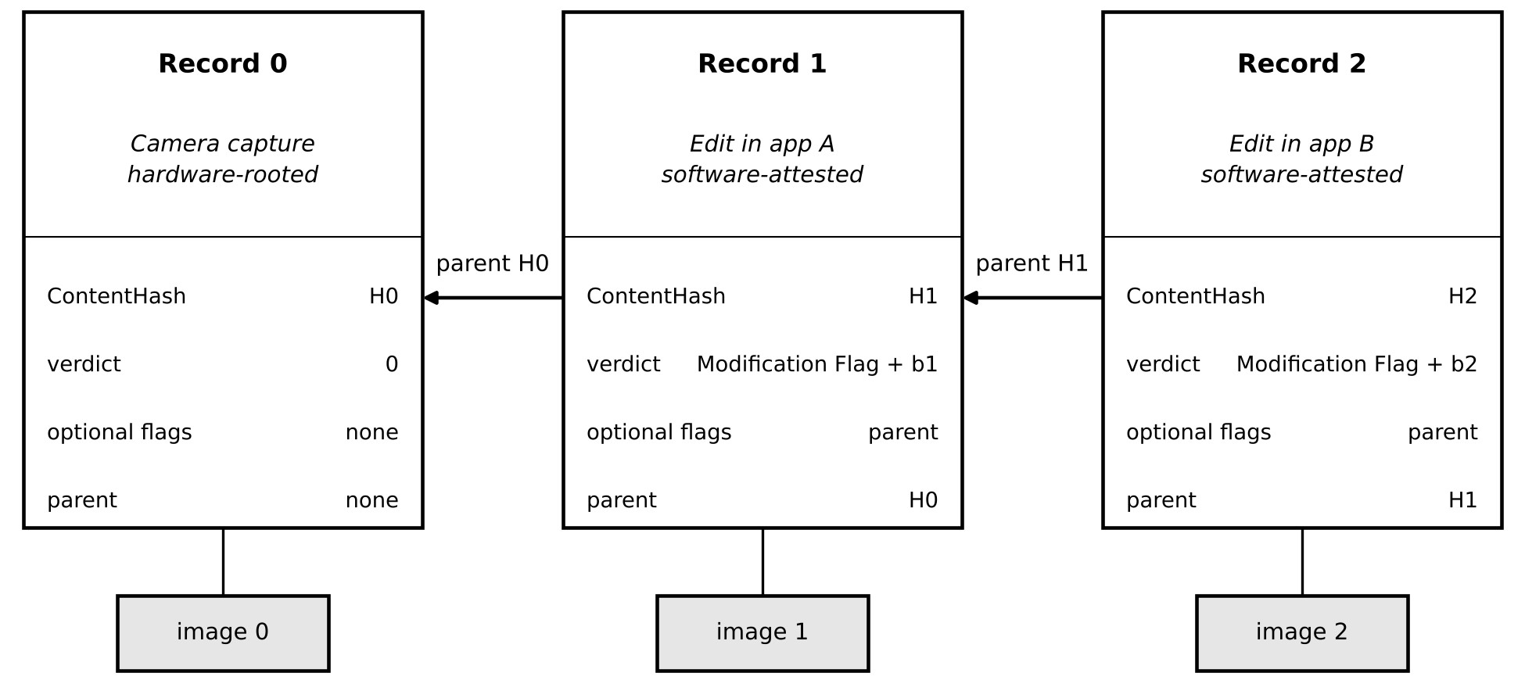
Figure 5. An edit chain: a camera capture followed by two edits. The verdict is the Modification Flag plus a deviation bucket (b1, b2). A capture has neither.

5.5 Trust Level
Edit authentication is software-attested, not anchored in an HRoT. The hardware-origin guarantee does not extend to the edit step, and it weakens R1 of the Protocol paper for edited records. The developer’s validator both runs the judgment software and applies the threshold, and no second party checks each judgment. The rules are published, so they can be audited. Attestation shows which platform registered a credential. Where the platform attests the application, as Play Integrity and App Attest do, it also shows which application. A TPM does not. Attestation does not show what the application did. A modified client with a valid registration can send a claim of zero deviation, and the validator cannot tell.
A checker maintained as an open-source project still needs an operator for the validator that serves it. A validator’s place on the Validator Allowlist held by the Registry Nodes depends on its compliance with the audit requirements. For a validator that serves credentials registered through a checker, those requirements include a current third-party audit of the checker release it accepts registrations from. A validator that lapses is removed from the Validator Allowlist, and the credential channel server cannot connect to it (Section 10.5). The release a user runs is self-reported, so the audit binds the operator and the project, and it does not bind a user who modifies the checker. Who operates the validator for an open-source checker, how often releases are audited, and how contributions to the list of operations are reviewed are not decided.

5.6 Unedited Reprocessing
If a platform recompresses, resizes or converts an image outside a CMPS, the bytes change, the ContentHash changes, and the chain to the original record is lost. The hash is exact by design (Section 6). Platforms with a reason to offer provenance checks have an incentive to use a CMPS, but the system cannot compel it.

6 VERIFICATION
A verifier hashes the content locally and queries the registry. No credential, subscription or intermediary is needed. The registry returns the record if one exists. It does not support attribution search, reverse lookup or photographer enumeration.
A match proves that the ContentHash was authenticated, and it returns the verdict. A non-match proves nothing. Content from manufacturers that do not take part has no record.
The match is exact. Any bit-level change outside a CMPS breaks it, including recompression and resizing that a viewer would not notice. A perceptual layer could sit on top of this one, but it would introduce false matches, because it treats similar images as the same. Verification survives the loss of in-band metadata, because the records are external. It does not survive a change to the pixel data.
Registry lookup latency is not measured.

7 TIMING AND DECOYS
The Protocol paper reports a simulation of timing and traffic analysis (its Appendix D). This section gives the parameters behind it and says what it does not test. It does not restate the experiment.
With 100 decoy transactions in flight, a passive observer names the device 4.77 percent of the time with one real transaction in flight and 2.02 percent with 150. The best-placed component, a content channel server, names it 5.53 and 2.39 percent of the time. No vantage can pick out a subset of its own guesses that is right more than half the time. Whether any deployment change would reduce the observer’s rate has not been tested.

7.1 Hold Parameters
Every hold uses one lottery shape: a 10-second tick, geometric release, and unconditional release at three times the hold’s mean. Table 3 gives the mean at each stage and the reason for it. A 120-second registry window gives a mean wait of 60 seconds. The holds on the three packets run in parallel, and F and I wait for the gatekeepers’ quorum, so the means are not additive.
Table 3. Mean hold at each stage.
Stage | Mean | Reason
Device, each content channel | 240 s | Role-aware: the device knows which channel it builds.
Device, credential channel | 120 s | Role-aware: the device knows which channel it builds.
First relays (A, D, G) | 60 s | A relay cannot tell which path it is on, so its mean depends on its hop position only. A first relay re-encrypts the routing code with the payload.
Second relays (B, E, H) | 300 s | A second relay forwards the payload alone. The two relay means add to 360 s along every path.
C, before sending to the validator | 30 s | Breaks the link between arrival at C and the validator query.
Validator, before replying | 30 s | Same, on the return.
C, fan-out to each gatekeeper | 20 s per draw | One draw at a time, so the three legs leave one after another.
Gatekeeper hold | 30 s | Randomizes when a packet is selected.
Gatekeeper departure bundle | 101 s | 30-second boundaries, 25% chance of boarding, unconditional at the 12th.
F and I, pre-match | 120 s | Role-aware: they know they are F or I.
F and I, post-match | 30 s | Keeps F and I from submitting together when quorum is slow.
Registry bundle wait | 60 s | Registry commit time is not a proxy for a server’s own submission.
The Protocol paper measures the holds as one set and does not attribute its result to any single hold. With every hold, lottery and schedule set to zero, the combined view of a node names the device 2.57 percent of the time with one real transaction in flight, against 1.49 percent for the observer (chance 0.55 percent), and it fails the claim criterion. With the holds in Table 3 it passes.

7.2 Latency Cost
In simulation the mean time from capture to finalization is 1,159 seconds with one real transaction in flight and 1,166 seconds with 150, about 19 minutes. The longest observed is 2,317 seconds, about 39 minutes. A photographer should expect a record to appear on that scale, not at once. The holds in Table 3 are deployment parameters, and each adds time to the record.

7.3 Padding Classes
Every leg except the board postings and the registry submissions is padded inside its transit encryption to a size drawn uniformly from 420 to 460 bytes. The gatekeeper fan-out uses a class of 820 to 860 bytes. With the sizes of Appendix A, the largest ordinary leg is 317 bytes, and each optional field adds 32 bytes, so every ordinary leg fits with room to spare. The fan-out is 690 bytes plus the V-Ring signature, which is 64 bytes with one validator. That fits its class for up to three validators. With more, the class must widen.

7.4 Decoys and Verdicts
About one hundred decoy transactions from registered decoy identities are in flight on average. Each is a genuine transaction and produces a permanent record. Its claim follows the real mix, so it carries a verdict like any other. A decoy’s optional-field flags follow the real mix too, and its parent flag matches its claim: a decoy whose claim describes an edit carries a parent ContentHash, and a capture decoy does not. Property E holds within one verdict class. A verdict that few records share narrows a validator’s candidates. If a fraction p of the candidate records share a verdict, a validator that sees it reduces its candidate set from N to pN. Table 4 shows the arithmetic for 1,000 candidates. It is illustrative, not measured.
Table 4. Effect of verdict rarity on a validator’s candidate set, for an assumed pool of 1,000.
Share of records with the verdict | Candidates left of 1,000 | Reading
50% | 500 | Common verdict. Little narrowing.
10% | 100 | Moderate narrowing.
1% | 10 | Rare verdict. Strong narrowing.
A real table needs the claim mix per manufacturer and for edits, which does not yet exist. The decoy generator must follow the real mix without leaking it. How it learns the mix is open.

7.5 Selective Denial
A compromised validator can withhold replies. This is outside the ProVerif models, because the symbolic adversary sees the order of registry outputs, and it is outside Appendix D, which tests passive adversaries only. No experiment supports this subsection. A validator that denies one device’s transactions can, together with a party who holds a candidate image and watches the registry, test one hypothesis per denial: if the image’s record never appears, the image may have come from that device.
Four mechanisms limit this. The holds make absence ambiguous, because a record may be late by many minutes. Bundling removes exact timing. Decoys mean the validator cannot tell whether a denied credential belongs to a real device. A validator that withholds at scale is visible to the operators who see missing replies, and can be removed from the Validator Allowlist. None of them makes the attack impossible. A patient adversary can wait beyond the longest hold, and the cost to a photographer is a transaction that never finalizes.

7.6 Edited Traffic
The simulation has no verdicts, edits or optional fields. All traffic is unedited with one verdict. The argument that edits leave the timing structure unchanged has three parts. Every leg is padded to its class. Optional fields add 32 bytes each and fit inside the padding. The hold lotteries do not depend on content. What the simulation does not model is the arrival pattern of edits, which may come in bursts after an editing session. That is untested.

8 DEVICE COST
None of the figures in this section is measured on this design. They come from published benchmarks for the primitives.

8.1 Primitives
A capture needs seven ECIES encryptions (Table 2, Section 3.4), which is fourteen elliptic-curve scalar multiplications, plus AES-256-GCM on inputs of a few hundred bytes. Bernstein and Schwabe report 527,102 cycles for one variable-base Curve25519 operation on an 800 MHz ARM Cortex-A8, the slowest and oldest hardware class this paper has in mind [7]. That is 0.659 ms. The three layers sent to a destination use an arbitrary base point G, so each needs two variable-base multiplications. The other four use the standard base point for the ephemeral key, so each needs one fixed-base and one variable-base multiplication. Ten variable-base multiplications take 6.6 ms. If every fixed-base multiplication costs as much as a variable-base one, the figure is 14 × 0.659 = 9.2 ms. A precomputed fixed-base multiplication is cheaper, so the real figure lies between 6.6 and 9.2 ms. AES-GCM at 5.6 cycles per byte on NEON is a small fraction of a millisecond. The 2 to 10 ms range quoted in the Protocol paper covers these operations and excludes hashing.

8.2 Hashing
Hashing the whole file is the larger cost. This paper assumes a RAW file of 25 to 35 MB, typical of a 24-megapixel sensor, and takes 30 MB as the central figure. eBACS reports about 13.7 cycles per byte for SHA-256 on long messages, measured on a 1 GHz Cortex-A8 board, in software [8]. Cycles per byte do not depend on the clock, so at 800 MHz that gives 430 to 600 ms. With ARMv8 crypto extensions, about 3.6 times faster, it is 120 to 170 ms. Hashing dominates the device-side budget.

8.3 Zero-Knowledge Comparison
Proving the same hash inside a zero-knowledge circuit is slower still. Flock, which has the highest SHA-256 proving throughput of the systems compared here, proves about 42,000 compressions per second on one core of an Apple M4 Max (Table 2 of [9]). A 30 MB file is 468,750 compressions of 64 bytes each, so Flock needs about 11 seconds on a desktop-class processor that no camera has. Flock does not yet provide zero-knowledge, so its figure is a floor. Hekate, a prover with zero-knowledge on, takes 949 ms for a 127.9 KiB SHA-256 message on an iPhone 14 Pro Max [19]. The figure is vendor-reported. At its marginal rate of about 7 ms per KiB, a 30 MB file takes about 200 to 220 seconds. That is a projection, not a measurement.
The worst case of this design, 430 to 600 ms, is about 19 to 26 times faster than the Flock figure and about 340 to 510 times faster than the Hekate projection. On a server, the SNARK libraries tested in zk-Bench take 8 to 134 seconds and 9 to 15 GB of memory to prove a 16 kB SHA-256 input [18], so a single circuit over a 30 MB file does not fit.
The ratios compare a camera’s hashing time with a prover’s time on a desktop core or a phone, so on camera hardware, which cannot run such a prover at that speed, they understate the gap. The cost argument is made for camera-class hardware. This design’s hashing is not benchmarked on phones or desktops, and their faster processors narrow the absolute gap. Credential-presentation systems such as Longfellow ZK [10] prove statements about a signed credential, not a hash of a 30 MB file, and the figures above do not apply to them (Section 9).

8.4 Attestation Comparison
Direct Anonymous Attestation would avoid the hashing cost inside a circuit. It would still need the coordinated-compromise argument, and it would not give the property this design has: the system holds no media content, so no party can attribute content, whatever the protocol layer. No DAA scheme is benchmarked.

8.5 What Is Not Measured
A benchmark on named hardware would turn the calculations above into measurements. It would cover the seven ECIES operations, AES-GCM and SHA-256 over a file of about 30 MB.

9 RELATED WORK
C2PA embeds signed manifests in media files [1]. Platforms strip metadata during compression and format conversion, which severs provenance at distribution. C2PA’s soft bindings, perceptual fingerprints that survive some transformations, partly address this. They trade guaranteed matching for tolerance of transformations, and they depend on a fingerprint-lookup service. Storing records outside the file, as this design does, makes survival of in-band metadata loss structural, without perceptual tolerance. The failure modes differ. C2PA’s provenance depends on metadata surviving. This design’s privacy depends on the independence of separately operated components. Table 5 maps the elements.
Table 5. Element mapping between C2PA and this design.
C2PA element | This design | Difference
Manifest with signed assertions | Registry record: ContentHash, verdict, optional hashes | External to the file. No assertion content.
Claim signature by a device certificate | Credential check by the validator, then ring signatures | No device signature. Anonymous within a set.
Hard binding (hash of the asset) | ContentHash over the whole file | Exact. Same property.
Soft binding (fingerprint lookup) | None | Exact matching only.
Ingredient (parent asset) | Parent ContentHash | Chain of hashes. No manifest copied.
Actions assertion | Modification Verdict | Five tool-class bits, an undeclared-change bit and four coarse deviation classes, not a list of actions.
Trust list | Validator Allowlist | Held by servers, not carried in the file.
Privacy Pass [11], Direct Anonymous Attestation [12] and Longfellow ZK [10] let a holder show a credential without revealing which holder it is. They address proving membership. Longfellow proves possession of an ECDSA-signed credential in zero knowledge, and its authors report ECDSA proofs in as little as about 20 ms and a few hundred milliseconds for a mobile-document presentation on mobile devices. This design addresses a different question: whether any component can assemble the link between a device and content at all (Protocol Section 6.1).
Other work addresses edits and the device signature. Google Pixel phones attach C2PA Content Credentials with signing keys generated in the StrongBox hardware of the Titan M2 chip. Android Key Attestation lets Google’s certificate authorities enroll a device without an account, the authorities keep no logs of IP addresses, and each image gets its own key and certificate, so that no two images share a public key [13]. That design keeps a per-image device signature, which this design omits so that no component holds a signer to attribute. VerITAS [14] and HyperVerITAS [15] prove in zero knowledge that an image is a permitted transformation, such as a crop, of a signed original. They give a cryptographic guarantee about the edit, which the deviation claim and the validator’s judgment in this design do not give (Section 5.5). They cost far more at the signer. VerITAS reports a proof of just over thirteen minutes for a 90 MB image on a weak signer such as a camera, and HyperVerITAS reports 6.6 minutes and 27 GB of memory for a 33 MP image on an Apple M3. They also start from a signed original, so they rest on the device signature that this design leaves out. Combining them with this design is not attempted.
Chong and van der Meyden show that global information-flow properties can be derived from an architecture’s structure together with local properties of its trusted components [16]. Their refinement results suggest a way to check that splitting one role, such as the validator, across cooperating parties preserves the proved properties. This direction is not pursued here.

10 GOVERNANCE REQUIREMENTS
This section states which governance protections the protocol structure leaves necessary and which it already provides. It does not say how any deployment governs and it does not describe how audits run.

10.1 Principle
Semantic Non-Assembly is structural. A policy that prohibits co-locating information is not Semantic Non-Assembly (Protocol Section 1.1). Governance preserves the independence and discard constraints that the structure assumes. The Protocol paper relies on it for the cross-role case, where the validator is compromised together with C or with a gatekeeper (Protocol Sections 4.6 and 6.2).

10.2 Necessary Protections
Table 6. Protections the structure leaves to governance.
Protection | What the structure provides | What governance must add | Source
Schema attestation | The validator’s schema can hold a mapping that the protocol cannot see. | An independent attestation that the schema supports membership queries and the transaction log only. | Section 4.3
Discard of values | Nothing forces a party to delete FullPacketHash, BlindShare_key, the signed Enc_FullPacketHash, C’s ring signature or the routing code. | A requirement to discard, checked by regular audit. | Protocol 3.2, 6.2
Operator independence | Properties hold only if operators of the same role do not share ownership, jurisdiction or stack. | Independence by ownership, jurisdiction and stack profile, which bounds same-role and cross-role compromise. | Protocol 4.1, 6.2
Honest jurisdiction tags | The device trusts the labels in its table. | Accurate labels in the device routing table. | Protocol 5
Key custody | Keys sit with operators. | Custody, rotation and revocation rules. | Sections 4.2, 4.3
Coarse timestamps | Operators may log fine timing. | Coarse windows in operational logs. | Protocol 6.2
Removal | The protocol cannot remove an operator. | Removal of an operator on compulsion or on violation of the constraints. | Protocol 6.2

10.3 Protections Already Provided
Table 7. Protections the structure already provides.
Protection | How the structure provides it | Source
Privacy against any single compromised component | Properties A, C, D, E, F, J and K hold with that component’s keys leaked. | Protocol 4, App. A.3
Trust in registry observers | An observer of the registry cannot identify a device (Property B). | Protocol App. A.2
Forgery by one compromised F, or by one or two gatekeepers | Properties G, H and I hold. | Protocol App. A.4
A compromised C attaching a genuine token to another FullPacketHash | Property L holds: the validator issues a verdict only for a wrapped FullPacketHash that the device committed to. | Protocol App. A.4
Linking through a single relay | Disjoint delivery paths and per-hop encryption. | Protocol 4.2 (R6)
Registry censorship resistance is a separate property and still depends on governance.

10.4 Detection Limits
Audits are regular. They detect after the fact and do not prevent. An adversary with enough control over governance could suppress the audit signal. The Protocol paper says the same (Section 6.2).

10.5 Validators Outside Governance
Manufacturers and developers operate validators outside consortium governance. The validator operator also controls the verdict policy (Section 4.6). In place of consortium governance, a validator must provide schema attestation, key revocation and transaction-log retention. Registry Nodes hold the Validator Allowlist. Removing a validator from it stops that validator’s verdicts from being accepted and stops C from connecting to it, until it is reliable again. Registration policy belongs to the operator in the same way as verdict policy. The operator should publish its attestation requirements, meaning which platforms and TPMs it accepts and what it checks at registration, so that a relying party can weigh an edit verdict by them. A claim about the size of an anonymity set should not rest on the validator’s own count of registered credentials. The same allowlist governs a validator that serves credentials registered through a checker (Section 5.5).

11 LIMITATIONS
Exact hashing. Any edit outside a CMPS breaks the chain to the original record. Edits are software-attested, not anchored in an HRoT, and this weakens R1 for edited records.
Anonymity sets are per manufacturer. A manufacturer with few devices has a small set. C learns the Token Key from the key reference, so against C the set is the devices that share that Token Key. Pooling widens the set and concentrates the exposure (Section 4.7).
Hardware credentials depend on secure-element integrity. Replicating a manufacturing-calibrated fingerprint takes access to manufacturing equipment, and no practical attack is publicly known, but that is an observation and not a bound. The credential is a bearer secret, so one extracted from a device lets an attacker produce tokens until it is revoked. Detection from usage patterns is not specified.
Edit credentials rest on platform attestation. Attestation is not available on every platform, and it tells the developer which device registered. A modified client with a valid registration can claim zero deviation. Published attacks have extracted keys from both firmware and discrete TPMs. The randomness hedges beyond the platform generator carry no claimed bit count (Section 3.11). The release of a separate checker is self-reported, and the audit gate binds its operator and not a user who modifies it (Section 5.5).
The Deviation Score measures undeclared change one step at a time. Undeclared changes that each stay under the validator’s threshold can add up over a chain of edits, although the class bits accumulate and the chain of records is public. A record holds one parent, so a composite of two registered images records only one of them.
The generator-blinded keys of Section 3.8 rest on a decisional Diffie-Hellman argument that covers ElGamal and not the AEAD layer. The key-derivation function is not analyzed, and the Diffie-Hellman argument does not cover a table holder who probes a candidate server (Section 3.8).
The system verifies hardware origin and not scene truthfulness. Staged scenes and photographs of screens pass.
Several things are not modeled or not tested: selective denial by a validator that withholds replies, the nonce table and the transaction log, the Optional-Field Flags byte, a compromised I acting alone, coordinated compromise of several components, and edited traffic in the timing experiment.
The system provides positive verification only. Content from manufacturers that do not participate has no record, so coverage is bounded by participation. The same holds for a CMPS.
First relays see the device IP address, and the validator sees the credential on every transaction and keeps a transaction log of dates and member-list references for up to three years. Operators should keep operational logs in coarse windows.

12 CONCLUSION
This paper specified what the Protocol paper assumed: the device that captures and builds tokens, the validator that judges a claim without reading the ContentHash, and the edit workflow that chains records. The device costs are calculated from published benchmarks, and no figure is measured on this design. The open parts of the device, the validator and the routing are the phone credential, the review of the blinded keys, the routing table’s jurisdiction handling, the bucket boundaries, the drain window and minimum size of a Token Key, the decoy claim mix, and recovery for a transaction that fails after the credential packet reaches its first relay. The open parts of the edit workflow and the analysis are the registration of editing credentials, the operator and the list of operations of an open-source checker, and the argument about selective denial. The paper states which governance protections remain necessary and which the structure provides. The system verifies hardware origin and nothing about the scene.

ACKNOWLEDGEMENTS
The author thanks Aspiration Tech for fiscal sponsorship and for legal and financial guidance.
Generative AI. The author designed the protocol before using any language model. The author then used Anthropic’s Claude (Sonnet 4.6, 5.0 and 5.5, and Opus 5.5) to draft and revise the manuscript, to write the simulation and enumeration scripts behind the figures in Section 3.9, and to check the manuscript for internal consistency and references. The author also used ChatGPT for adversarial review. The author made all design decisions, evaluated each suggestion, and is responsible for the content of this paper.
Funding. This work received no grant funding.
Competing interests. The author is the founder of the Birthmark Standard Foundation, which develops the Birthmark Protocol specified in this paper.

REFERENCES
[1] Coalition for Content Provenance and Authenticity. C2PA Technical Specification, Version 2.4. 2026. https://spec.c2pa.org/specifications/specifications/2.4/specs/C2PA_Specification.html
[2] Ryan, S. The Birthmark Protocol: Achieving Semantic Non-Assembly in Media Provenance. arXiv:2606.22311, 2026. (arXiv preprint; not independently peer-reviewed.) Companion repository: https://github.com/Birthmark-Standard/Protocol
[3] Barnes, R.; Bhargavan, K.; Lipp, B.; Wood, C.A. Hybrid Public Key Encryption. RFC 9180, IETF, February 2022.
[4] Thomson, M.; Wood, C.A. Oblivious HTTP. RFC 9458, IETF, January 2024.
[5] Moghimi, D.; Sunar, B.; Eisenbarth, T.; Heninger, N. TPM-FAIL: TPM meets Timing and Lattice Attacks. 29th USENIX Security Symposium, 2020. arXiv:1911.05673.
[6] Jacob, H.N.; Werling, C.; Buhren, R.; Seifert, J.-P. faulTPM: Exposing AMD fTPMs’ Deepest Secrets. arXiv:2304.14717, 2023.
[7] Bernstein, D.J.; Schwabe, P. NEON Crypto. CHES 2012. LNCS vol. 7428, pp. 320–339. DOI: 10.1007/978-3-642-33027-8_19.
[8] Bernstein, D.J.; Lange, T. (eds.). eBACS: ECRYPT Benchmarking of Cryptographic Systems. https://bench.cr.yp.to (accessed 2026).
[9] Bünz, B.; Rothblum, R.D.; Wang, W. Flock: Fast Proving for Batch Boolean Computations. arXiv:2607.27491, 2026. Also IACR Cryptology ePrint Archive, Paper 2026/1329.
[10] Frigo, M.; shelat, a. Anonymous Credentials from ECDSA. Communications in Cryptology, vol. 3, issue 1, 2026. Also IACR Cryptology ePrint Archive, Paper 2024/2010.
[11] Davidson, A.; Iyengar, J.; Wood, C.A. The Privacy Pass Architecture. RFC 9576, IETF, June 2024.
[12] Brickell, E.; Camenisch, J.; Chen, L. Direct Anonymous Attestation. Proceedings of the 11th ACM Conference on Computer and Communications Security (CCS), pp. 132–145, 2004. DOI: 10.1145/1030083.1030103.
[13] Lynch, E.; Hanna, S. How Pixel and Android are bringing a new level of trust to your images with C2PA Content Credentials. Google Security Blog, September 10, 2025. https://security.googleblog.com/2025/09/pixel-android-trusted-images-c2pa-content-credentials.html
[14] Datta, T.; Chen, B.; Boneh, D. VerITAS: Verifying Image Transformations at Scale. IACR Cryptology ePrint Archive, Paper 2024/1066, 2024.
[15] Greiner, G.; Mowery, T.; Soni, P. HyperVerITAS: Verifying Image Transformations at Scale on Boolean Hypercubes. Proceedings on Privacy Enhancing Technologies, 2026(2), pp. 58–75. DOI: 10.56553/popets-2026-0036.
[16] Chong, S.; van der Meyden, R. Using Architecture to Reason About Information Security. ACM Transactions on Information and System Security, 18(2), Article 8, 2015. DOI: 10.1145/2829949.
[17] Bellare, M.; Boldyreva, A.; Desai, A.; Pointcheval, D. Key-Privacy in Public-Key Encryption. ASIACRYPT 2001, LNCS vol. 2248, pp. 566–582. DOI: 10.1007/3-540-45682-1_33.
[18] Ernstberger, J.; Chaliasos, S.; Kadianakis, G.; Steinhorst, S.; Jovanovic, P.; Gervais, A.; Livshits, B.; Orrù, M. zk-Bench: A Toolset for Comparative Evaluation and Performance Benchmarking of SNARKs. Security and Cryptography for Networks (SCN 2024), LNCS vol. 14973, pp. 46–72, 2024. Figures cited from the preprint: IACR Cryptology ePrint Archive, Paper 2023/1503.
[19] Oumuamua Labs. Mobile ZK Benchmarks (hekate-mobile 0.3.0). https://oumuamua.dev/mobile/benchmarks, published 12 October 2026, accessed 24 October 2026. Vendor-reported; not peer reviewed.

APPENDIX A: WIRE FORMATS
Notation: || is concatenation. ECIES is randomized IND-CCA2 public-key encryption. AEAD is AES-256-GCM. Sign is Ed25519. RSign is an unlinkable 1-of-n ring signature. Table A.1 gives field sizes and Table A.2 gives every leg of one transaction.
Table A.1. Field sizes.
Field | Size | Notes
Cred_HW, Cred_SW | 32 B | Secret credential. Estimate.
key_ref | 8 B | Estimate.
n | 16 B | 128-bit random.
replay_nonce | 16 B | 15-bit UTC day count, offline bit and 14 random bytes.
claim | 2 B | Estimate. Five class bits and a Deviation Score. The encoding of the Deviation Score is not fixed.
tx_id | 16 B | Random, generated by C.
flags | 1 B | In ContP_F, the FullPacketHash input, the σ_F input and the registry record.
verdict | 1 B | Six Modification Flag bits and a two-bit deviation bucket. Bit positions not fixed.
ContentHash, FullPacketHash, h(metadata), parent ContentHash, binding_hash, BlindShare_key | 32 B each | SHA-256 outputs, and a 256-bit AEAD key.
Enc_FullPacketHash | 48 B | AEAD(BlindShare_key; FullPacketHash): 32 B plus a 16 B tag. A fixed AEAD nonce is safe because BlindShare_key is single-use. The device, C and the gatekeepers compute it from the same inputs and get the same bytes.
Routing code rc | 16 B | Per-transaction identifier for a destination.
ECIES overhead | 49 B | Per encryption. Derived from the spec’s sizes.
σ_V | about 64 B with one validator | V-Ring signature. Close to a plain signature with one validator; grows with the number of registered validators.
σ_C | 576 B | C-Ring signature over a 17-node pool.
σ_GK, σ_F, σ_I | 64 B each | Ed25519.
Table A.2. The 19 legs of one transaction. Starred sizes are estimates. Every leg except the board postings and the registry submissions is padded inside its transit encryption to 420 to 460 B, and the gatekeeper fan-out to 820 to 860 B. A key named X-transit is X’s Server Transit Key.
Leg | From → to | Contents | Encrypted under | Raw size
CredP-1 | Device → A | rc_C, CredP | A-transit | 317 B*
CredP-2 | A → B | rc_C, CredP | B-transit | 317 B*
CredP-3 | B → C | CredP | C-transit | 301 B*
ContP_F-1 | Device → D | rc_F, ContP_F | D-transit | 163 B
ContP_F-2 | D → E | rc_F, ContP_F | E-transit | 163 B
ContP_F-3 | E → F | ContP_F | F-transit | 147 B
ContP_I-1 to 3 | Device → G → H → I | As ContP_F-1 to 3, with rc_I and ContP_I | G, H, I-transit | 163 / 163 / 147 B
CV-1 | C → V | tx_id, T, key_ref, Enc_FullPacketHash | V-transit | 252 B*
CV-2 verdict | V → C | tx_id, verdict, σ_V | C-transit | 130 B*
CV-2 reject | V → C | tx_id, REJECTED. No signature, padded to the verdict class | C-transit | 130 B*
GK (three legs) | C → each gatekeeper | FullPacketHash, verdict, σ_V, BlindShare_key, σ_C | GK-transit | 690 B* plus σ_V size
Post (three legs) | Each gatekeeper → its match board | FullPacketHash, verdict, σ_C, σ_GK | Registry Node access only | 673 B
Reg-F, Reg-I | F, I → Registry Node | ContentHash, verdict, flags, [h(metadata)], [parent], σ_F or σ_I | Registry Node transit | 98 B* plus 32 B per optional field
Signatures. σ_V = RSign(V-Ring; verdict || Enc_FullPacketHash), produced for every verdict and not on rejection. σ_C = RSign(C-Ring; FullPacketHash || verdict). σ_GK = Sign(GK-sign_sk; FullPacketHash || σ_C). σ_F = Sign(F-sign_sk; ContentHash || verdict || flags || [h(metadata)] || [parent ContentHash]), and σ_I the same under I-sign_sk. σ_V, σ_C and σ_GK never reach the registry. σ_F and σ_I travel with the submissions to the registry, where Registry Nodes verify them at intake and drop them. Both σ_V and σ_C cover the verdict, so no party after the validator can change it. V-Ring hides which validator signed from the gatekeepers and boards. It does not hide the validator from C, which sends CV-1 to the validator that key_ref names. With one registered validator it hides nothing.
Registry record. A finalized record is 42 bytes for a capture: ContentHash 32, verdict 1, flags 1 and an 8-byte coarsened timestamp. Each optional field adds 32 bytes, so a record is 74 bytes with one and 106 bytes with both. The record names neither F nor I. It holds no device identifier, no manufacturer identifier and no identity of C or a gatekeeper.
Table A.3. Registry record. Totals: 42 B, 74 B with one optional field, 106 B with both, as the Protocol paper states in R5.
Field | Size | Notes
ContentHash | 32 B | SHA-256 of the candidate image.
verdict | 1 B | One byte: the Modification Flag and the deviation bucket.
flags | 1 B | Marks which optional fields are present.
Timestamp | 8 B | Posting time, coarsened.
h(metadata) (optional) | 32 B | Enables selective disclosure without putting values on-chain.
Parent ContentHash (optional, edits only) | 32 B | Lets holders of both images check the relationship directly.

